**DBMS Assignment 1: Basic SQL**

|  |  |
| --- | --- |
| Name: Omkar Oak | MIS: 112103099 |
| Div: 2 | Batch: T1 |

**Statement**: Write the simple SQL queries on the given schema.

1. Write the following simple SQL Queries on the University Schema.

* Find the names of all the students whose total credits are greater than 100.

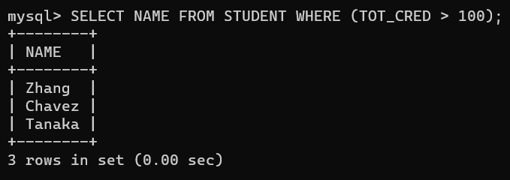

* Find the course id and grades of all courses taken by any student named 'Tanaka'.

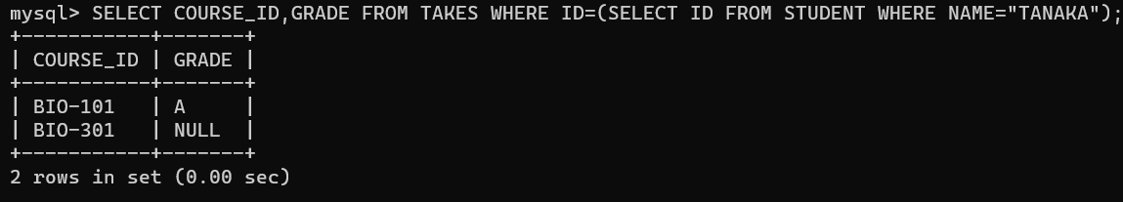

* Find the courses which are offered in both 'Fall' and 'Spring' semester (not necessarily in the same year).

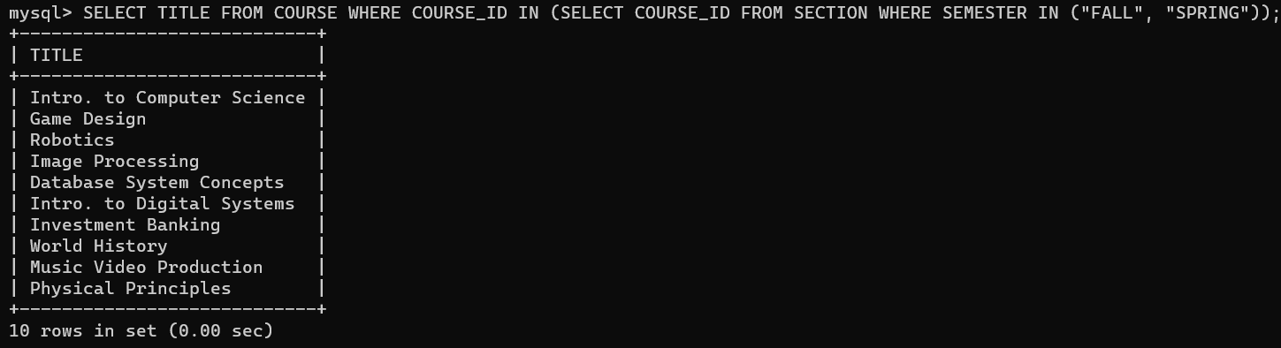

* Find the names of all the instructors from Comp. Sci. department.

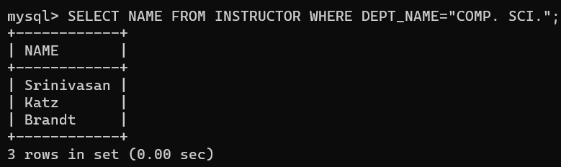

* Find the course id and titles of all courses taught by an instructor named 'Srinivasan'

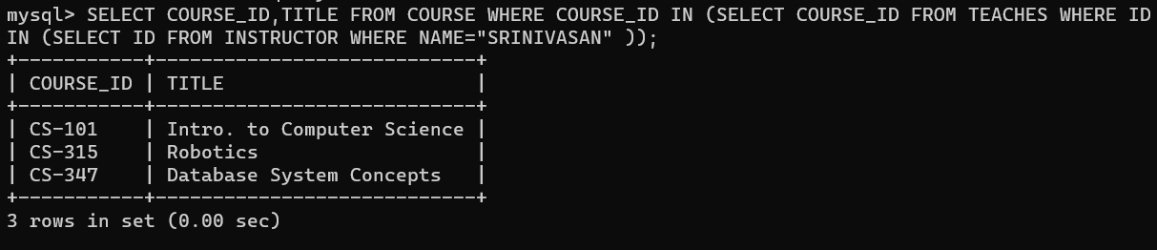

* Find the names of instructors who have taught at least one course in Spring 2009.

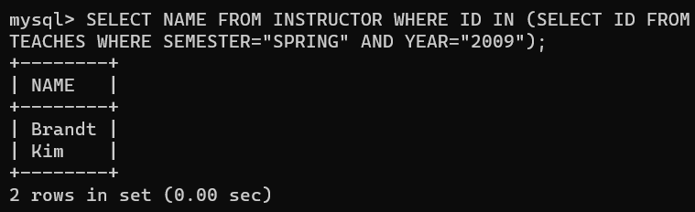

1. Create the Railway schema using the commands in the [Railway DDL](http://www.it.iitb.ac.in/moodle/pluginfile.php/77066/mod_assign/intro/RailwayDDL.sql)script; The DDL script also contains a description of the railway Schema. Insert sample data using the command in the file [SampleRailwayData](http://www.it.iitb.ac.in/moodle/pluginfile.php/77066/mod_assign/intro/railwayInsertFile.sql).

Write the following Queries for Railway Schema.

* Find pairs of stations (station codes) that have a track (direct connection) with distance less than 20Kms between them.

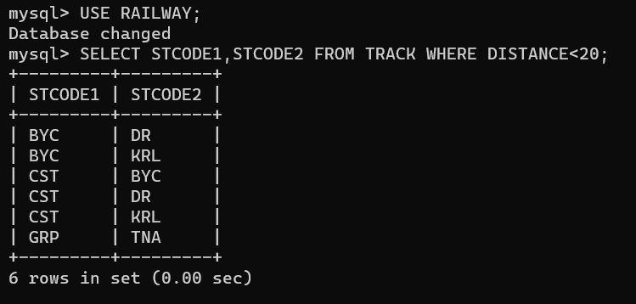

* Find the IDs of all the trains which have a stop at THANE

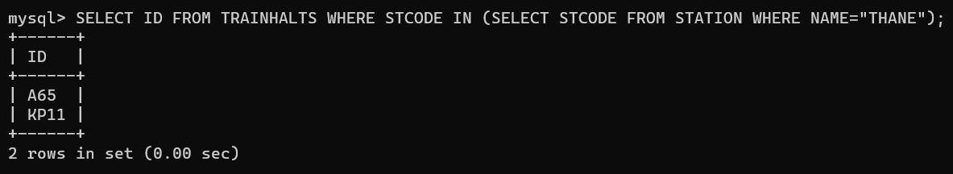

* Find the names of all trains that start at MUMBAI.

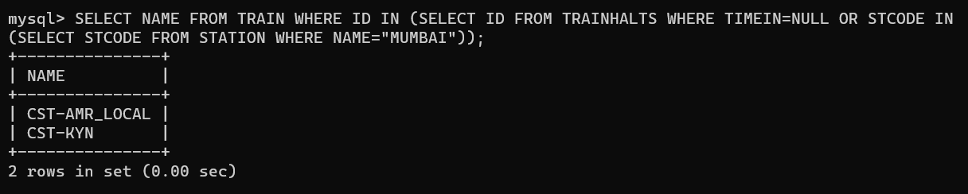

* List all the stations in order of visit by the train 'CST-AMR_LOCAL'.

